NAME:
Year 9 Term 4 – Body Systems
Revision SHEET No. 1
Learning Goal 1: Understand the role of the digestive system in the human body

- Use the following words to arrange in levels of complexity: Cell, Organism, Tissue, Body system, Organ

__ Cell _____ Tissue _______ Organ ______ Body system ______Organism ___

- List four nutrients used by the body AND two waste products that are removed from the body.
Could include any of the 7 major nutrients, but recommend the following:
Nutrients (4) – Oxygen, carbohydrates, proteins, fats
Wastes (2) – Carbon dioxide, urea
- What is the function of the following in digestion:
- Small intestine: Digest (breakdown) and absorb carbohydrates, proteins,and fats into the bloodstream
- Oesophagus: Transports food from the mouth to the stomach
- Stomach: begin breakdown of proteins and acid level destroys harmful microorganisms
- Pancreas: synthesis digestive enzymes (pancreatic juice) – amylases, proteases, lipases – which are released into top of the small intestine (duodenum)
- Liver: Processes the nutrients absorbed into the bloodstream
- Large Intestine: Absorbs water and salts to make faeces
- Write a definition and give an example of each of the following terms:
- Tissue: Collection of similar (specialised) cells working together
- Organ: Group of tissues working together
- Body System (organ system): Different organs working together
- Organism: Living thing

- Label the organs in the following diagram:
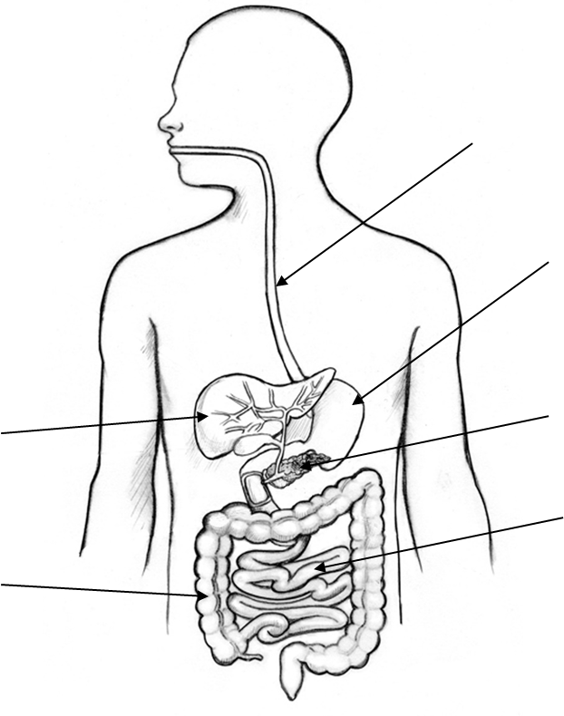
Word List: Oesophagus, Large Intestine, Small Intestine, Pancreas, Liver, Stomach
Oesophagus
Stomach
Liver
Large
Intestine
Pancreas
Small Intestine
- List two body systems which work together to provide nutrients and remove wastes. Write one sentence on each system describing its role in providing the nutrients and/or removal of the waste product.
Answers will vary – Must include either the digestive system or the respiratory system as these provide the nutrients, and most commonly also include the circulatory system. Example -
- Digestive System = provides nutrients by breaking down food and absorbing the nutrients into the bloodstream. Waste is removed after digestion is complete, as faeces.
- Circulatory system = transport the nutrients throughout the body to cells, and transport wastes such as carbon dioxide to the lungs for release.
- What is the difference between mechanical digestion and chemical digestion? Give an example of each.
Mechanical is the physical movement of food so that it is broken into smaller pieces. An example is chewing in the mouth or churning of the stomach.
Chemical digestion is the breakdown of large food molecules into small molecules by enzymes. Examples of this is amylase breaking down carbohydrates, proteases breaking down proteins, and lipases breaking down fats. Accept specific example such as pepsin in the stomach.

Learning Goal 2: Understand the role of the circulatory system in the human body
- Write a description for each of the following blood components including the component’s main function:
Plasma: Water component of blood, contains and transport all water soluble compounds.
White Blood Cells: Cells in blood which recognise and destroy foreign microorganisms in the body
Red Blood Cells: Tiny red cells which bind to and carry Oxygen

- Label the parts of the heart in the following diagram:
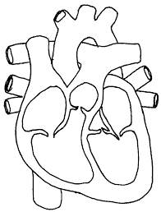
Word List: Left Atrium, Right Atrium, Left Ventricle, Right Ventricle, Aorta, Pulmonary Vein, Pulmonary Artery, Vena Cava
Aorta
Pulmonary Artery
Pulmonary
Vein
Pulmonary
Vein
Left atrium
Right atrium
Right ventricle
left ventricle
Vena cave, or Great vain

- Describe the function of the following three types of blood vessels:
Arteries: Carry blood away from the heart (do not mention oxygenated blood)
Veins: Carry blood towards from the heart (do not mention deoxygenated blood)
Capillaries: Transport blood to all the cells in the body

- If you came across a blood vessel, how could you tell if it was:
An artery? Larger vessels, very thick (whitish) walls. Blood pulses in arteries (blood flow is not continuous)
A vein? Larger vessels, thin walls. Blood flow is continuous (no pulse is felt in veins).
A capillary? Very small vessels, very thin walls.

Learning Goal 3: Understand the role of the respiratory system in the human body
- Label the parts of the respiratory system in the following diagram:
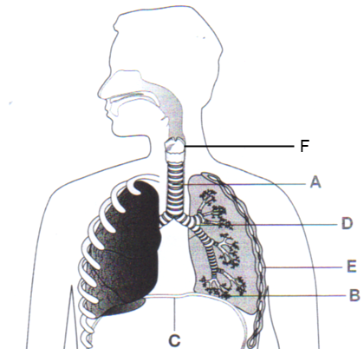
Word List: Mouth, Nose, Trachea (wind pipe), Diaphragm, Bronchi, Larynx, Rib
C
D=
E
F
G
H
Larynx
Trachea
Brochi (leading to bronchiole)
ribs
Alvioli
Diaphragm

A
Nasal Cavity
B
Mouth

- Why do marathon runners train in high altitude locations?
At high altitudes there is less oxygen in the air. Therefore the body adapts to this by making more red blood cells. Having more red blood cells means more oxygen can be absorbed into the bloodstream. When the athlete returns to sea level, they will have more red blood cells than athletes who train a sea level. This should allow them to absorb more oxygen during athletic events and have a higher aerobic capacity. This means they can run further and at a faster rate than other athletes.
- Describe the process of gas exchange in the lungs. You should include the names of the gases and the direction they are exchanged, the parts of the lungs and circulatory system involved. (eg Alveoli).
- Diaphragm contracts creating low air pressure in the lungs
- Air is forced into lungs by pressure difference.
- Air travels through the trachea, bronchi, bronchiole, into the alveoli.
- Within the alveoli the oxygen is absorbed from the air in the alveoli, through the lining of the alveoli into the bloodstream (capillaries of the circulatory system). At the same time Carbon dioxide is absorbed into the air in the alveoli from the blood stream.
- The diaphragm relaxes and high air pressure is created in the lungs, and air is forced out of the lungs.

